SMITH-ATLAS AGENT GENERATOR ASSISTANT
IMPLEMENTATION AND USER GUIDE
SA-1006-V1

Table of Contents

I. About 1
II. User Guide 2
III. One-Time Assistant Setup Instructions 6
1. Name 6
2. Description 6
3. Instructions 7
4. Knowledge 7

About

Version | SA-1006-V1
Release Date | July 21, 2026
Developer(s) | Matt G. Smith
Contact Information | matt@smith-atlas.com
Purpose | This AI-powered assistant helps users develop AI system prompts for their own custom agents (e.g., Claude Projects, Gemini Gems, ChatGPT GPTs, Copilot Agents).
AI Solution & Model | The system instructions are designed to be AI tool agnostic—meaning that Gemini, Claude, ChatGPT, Copilot, and in-house solution, etc., users can implement these system instructions in their Gems, Projects, GPTs, Agents, and Assistants, respectively.

User Guide

- Open your Assistant titled “Smith-Atlas Agent Generator Assistant (SA-1006-V1).”

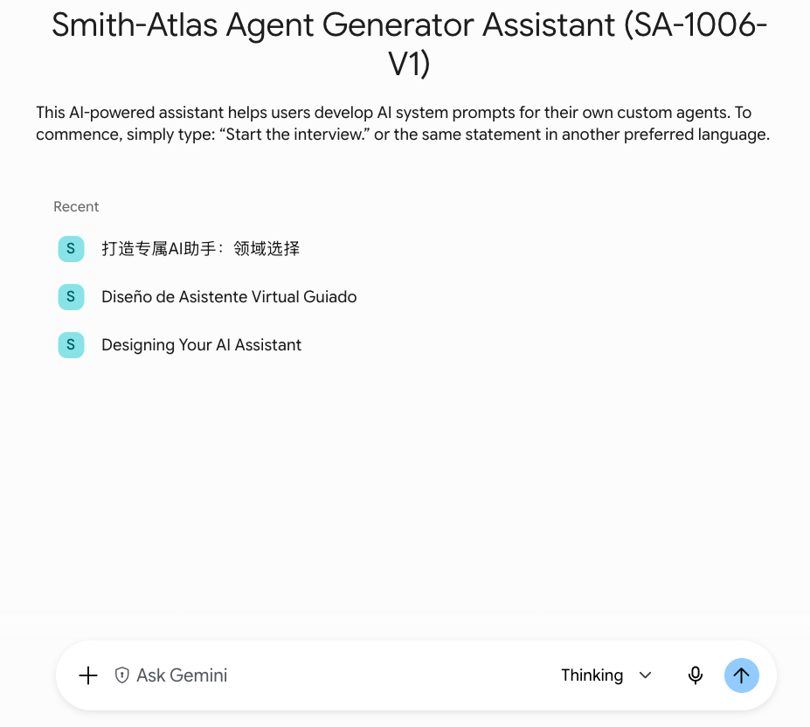

- Copy and paste the following blue font prompt into your Assistant’s chat area:

Start the interview.



or in another preferred language:



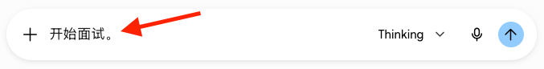
- Change your AI model to your most capable model (e.g., Thinking, Pro, High).

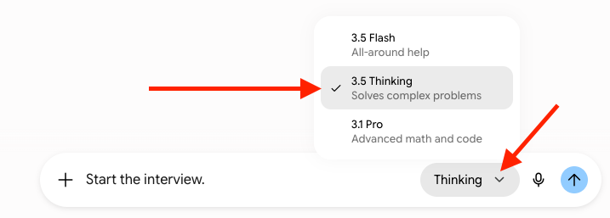

- Press “Enter/Return” on your keyboard or click “Submit” or similar on your Assistant’s chat interface.

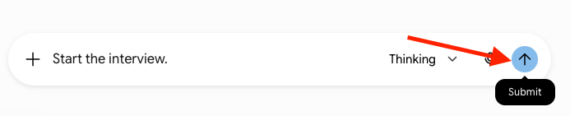

- Answer the interview questions thoughtfully and completely. The amount of effort you put into the interview is proportional to the output quality.

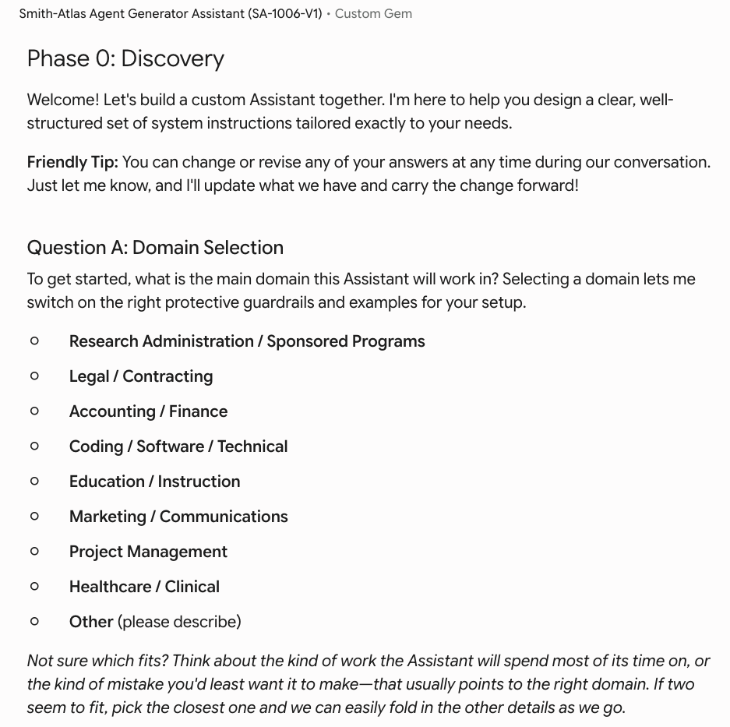
- The Assistant will prepare the following deliverables:

  - The new Assistant’s title (the “Assistant Title”)

  - A short description for the new Assistant (the “Short Description”)

  - “Loader.txt” and “Process.txt” system prompts for the new Assistant (collectively, the “Original System Prompts”)

  - The kick-off prompt to start the new Assistant (the “Kick-off Prompt”)

  - Brief instructions for how to set up the new Assistant

- Optional: Ask another LLM for feedback on the Original System Prompts

  - Background

    - While the Original System Prompts are ready to be used in your Assistant, it can be useful to have another LLM provide feedback on them. If you’re interested, please follow the suggested process below.

  - Process

    - Open an LLM (e.g., Claude, ChatGPT, Gemini) that’s different from the one you used to develop the Original System Prompts.

    - Change the model to the most sophisticated that’s available (e.g., Thinking, Pro, High).

    - Type the following into the chat area: Please carefully read and understand the attached “Loader.txt” and “Process.txt” system prompts for an AI agent. I will give you further instructions.” Do not press Enter/Return on your keyboard.

    - Upload the Loader.txt and Process.txt files into the chat area and press Enter/Return on your keyboard.

    - Once it finishes processing, type the following into the chat area: Please evaluate whether I should make any revisions to the Loader.txt and/or Process.txt system prompts to incorporate any missing best practices or to correct any errors. Then press Enter/Return on your keyboard.

    - Respond to the new LLM’s questions (using the phrase “Please ask me any clarifying questions.” if you think something might be vague to the LLM or it doesn’t seem to understand you.

    - Once you’ve completed the back-and-forth dialogue, type the following into the chat area: Based on the responses I provided above, please rewrite the entire Loader.txt and Process.txt system prompts in markdown language in two separate code blocks, so it is easy to copy and paste them into other documents.

    - Copy (or download) the updated system prompts (collectively, the “Updated System Prompts”).

    - Go back to the original LLM that produced the Original System Prompts. In the chat area, type: I asked [NEW LLM NAME] to review these “Loader.txt” and “Process.txt” system prompts and provide feedback. Please evaluate what [NEW LLM NAME] suggested. What elements, if any, should we incorporate into the system prompts? Do not press Enter/Return on your keyboard.

    - Paste the entire Updated System Prompts into the chat area below the language in blue above, or attach the Updated System Prompts to the chat area. Then press Enter/Return on your keyboard.

    - Respond to the original LLM’s questions (using the phrase “Please ask me any clarifying questions.” if you think something might be vague to the original LLM or it doesn’t seem to understand you.

    - Once you’ve completed the back-and-forth dialogue, type the following into the chat area: Based on the responses I provided above, please rewrite the entire “Loader.txt” and “Process.txt” system prompts in markdown language in a code block, so it is easy to copy and paste into another document.

    - You can iterate this approach as desired (including at a future date if you want to adapt some aspect of the Assistant). Once you’re comfortable with the output, go to the next step.

- Individually copy the Assistant Title, Short Description, and “Loader.txt” system prompt and paste them into your new Assistant.

  - See 6.a through 6.c above for more information.

  - You can use the steps from One-Time Assistant Setup Instructions below for guidance on how to set up these three elements of the new Assistant that you created. Please note that the language in the One-Time Assistant Setup Instructions guides how to first establish the Smith-Atlas Agent Generator Assistant (SA-1006-V1); however, these steps are very similar for your new Assistant but with different text/code.

- Upload the “Process.txt” system prompt to your Assistant’s “Knowledge.”

  - See 6.c above for more information.

  - You can use the steps from One-Time Assistant Setup Instructions below for guidance on how to add “Knowledge” to the new Assistant that you created. Please note that the language in the One-Time Assistant Setup Instructions guides how to first establish the Smith-Atlas Agent Generator Assistant (SA-1006-V1); however, these steps are very similar for your new Assistant but with different text/code.

- Your Assistant is ready for use.

- End instructions.

One-Time Assistant Setup Instructions

Name

Copy and paste the following blue text into your AI agent’s name field:

Smith-Atlas Agent Generator Assistant (SA-1006-V1)

Description

Copy and paste the following blue text into your AI agent’s description field:

This AI-powered assistant helps users develop AI system prompts for their own custom agents. To commence, simply type: “Start the interview.” or the same statement in another preferred language.

Instructions

Copy and paste all of the text from the SA-1006-V1_Loader.txt file into your Assistant’s Instructions field, exactly as written (including the formatting symbols, as they are part of the instructions).

Knowledge

Upload the SA-1006-V1_Process.txt file into your Assistant’s internal “Knowledge.” Do not change the file name.

Some AI tools have a limited amount of space for system prompts (~8,000 characters); the “Loader” system prompt is designed to fit within this limited character space. The “Process” system prompt contains the remaining instructions your Assistant will need, and is attached to the Assistant’s knowledge.
If your AI solution can generate files, you might instead ask it to generate text two text files instead of the two code blocks. The revised language would be: Based on the responses I provided above, please revise the entire “Loader” and “Process system prompts in markdown language and generate two separate .txt files–one for each system prompt.
If your AI solution can generate files, you might instead ask it to generate text two text files instead of the two code blocks. The revised language would be: Based on the responses I provided above, please revise the entire “Loader” and “Process system prompts in markdown language and generate two separate .txt files–one for each system prompt.
When working with outputs of the Smith-Atlas Agent Generator Assistant (SA-1006-V1), this file will be titled Loader.txt.
When working with outputs of the Smith-Atlas Agent Generator Assistant (SA-1006-V1), this file will be titled Process.txt.

